Cairo University  
Faculty of Computers and Artificial Intelligence



**CS251**

**Software Engineering I**

GoFo - “Go Football”

Software Design Specifications

Version 1.0

|  |  |  |
| --- | --- | --- |
| ID | Name | Email |
| 20190320 | Abdelrahman Mohamed Abdelzahir | a.bakkar131313@gmail.com |
| 20190281 | Abdelhaleem Mahmoud Abdelhaleem **(S8)** |  |
| 20190200 | Rabab Soliman Khedr |  |

6 & 2021

Contents

Team 3

Document Purpose and Audience 3

System Models 4

I. Class Diagram(s) 4

II. Class Descriptions 5

III. Sequence diagrams 6

Class - Sequence Usage Table 10

IV. State Diagram 11

Tools 11

Ownership Report 12

# Team

|  |  |  |  |
| --- | --- | --- | --- |
| **ID** | **Name** | **Email** | **Mobile** |
| 20190320 | Abdelrahman Mohamed Abdelzahir | a.bakkar131313@gmail.com | 01018307127 |
| 20190281 | Abdelhaleem Mahmoud Abdelhaleem **(S8)** |  |  |
| 20190200 | Rabab Soliman Khedr |  |  |

# 

# Document Purpose and Audience

* The document is about class diagram(S) and sequence diagram(s) and. And these diagrams to facilities reading to readers. It is ready to be read by developers, Programmers and clients.
* Developer, Programmer and Clients.

# System Models

## I. Class Diagram(s)

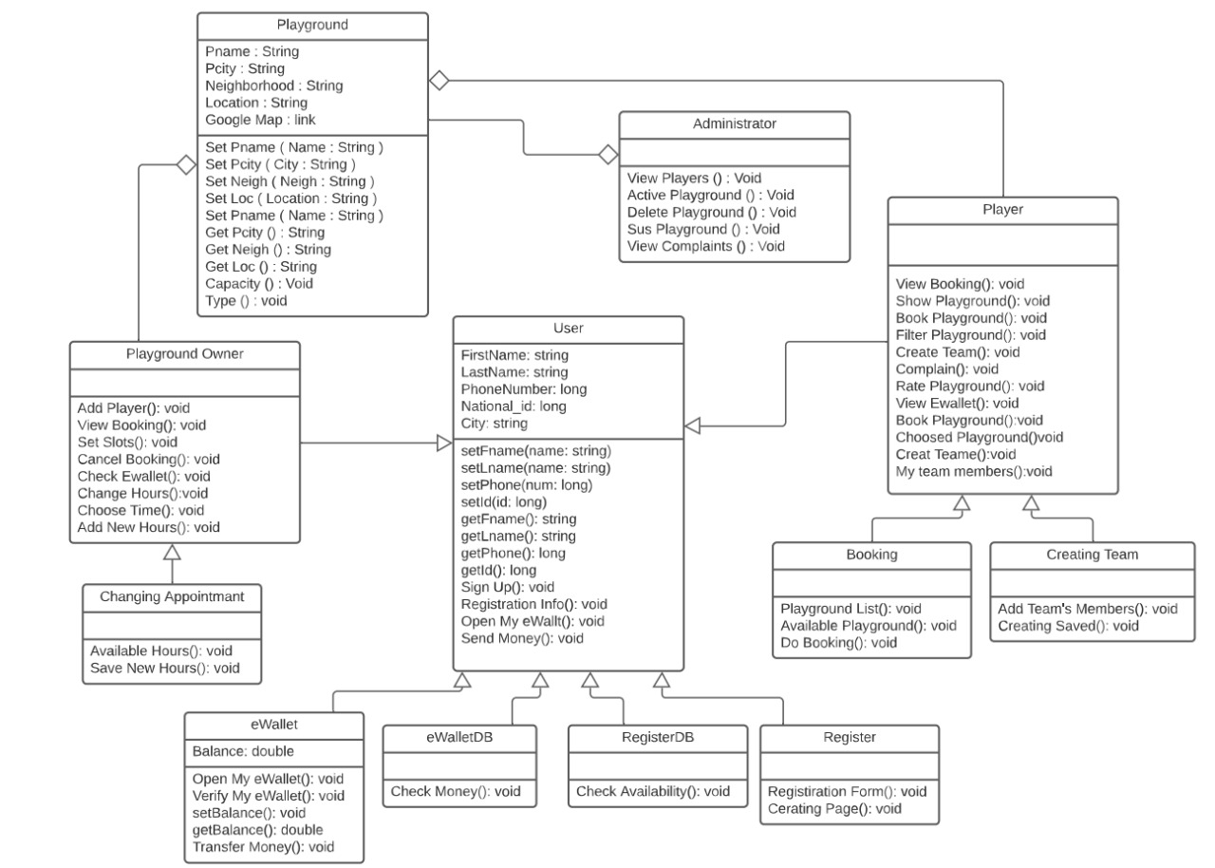

**II. Class Descriptions**

| **Class ID** | **Class Name** | **Description & Responsibility** |
| --- | --- | --- |
| 1 | User | Responsible for recording and saving the data of all users. |
| 2 | Player | Through the chapter the user can search for stadiums, book a stadium. Send an invitation to his friends and delete a reservation. |
| 3 | PlaygroundOwner | A class that inherits User, and allows an owner to add (own) playgrounds and control them |
| 4 | Playground | Class IS the Pitch measurements of the stadium location, stadium price and hours available by the stadium owner. |
| 5 | Administrator | It can suspend stadiums and add stadiums and permanently delete them so players cannot them if they find complaints or violate the laws. |
| 6 | Creating team | He has thought. To add a stadium, adjust his hours, and set a specific price per hour. |
| 7 | eWalletDB | A boundary class for users whether players of owners to check their eWallet balance, deposit using an external service, or withdraw their money. |
| 8 | E-Wallet | A class that has the responsibility of controlling financial operations in the system, and can be connected to an outside method like Fawry, and any User must have one eWallet. |
| 9 | RegistingDB | Checks if this team is available to register |
| 10 | Register | A register is an authoritative list of one kind of information |
| 11 | Booking | He booked the place for a specific time and organized |

## III. Sequence diagrams

**1-**

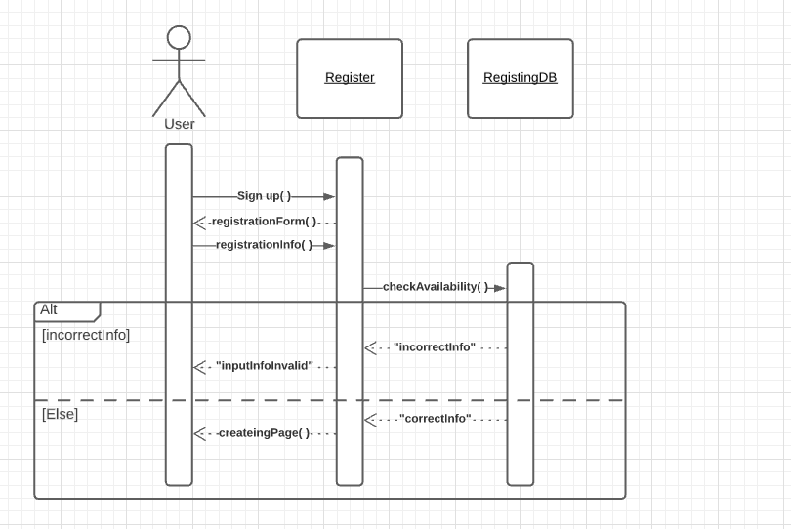

**2-**

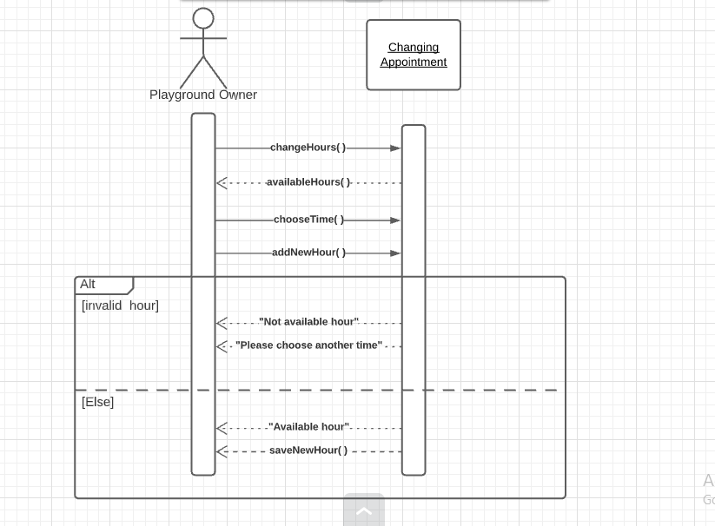

**3-**

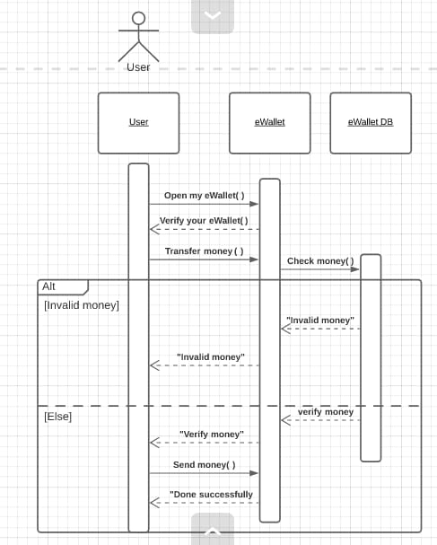

**4-**

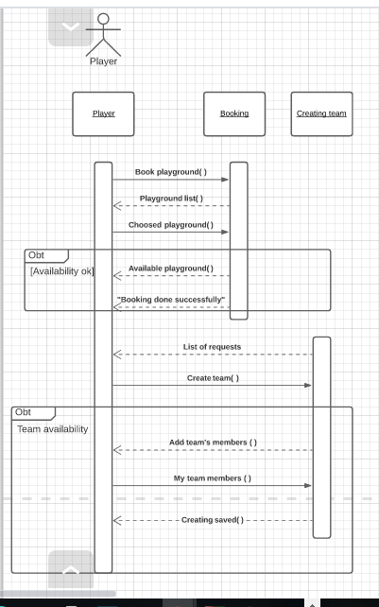

### 

### Class - Sequence Usage Table

| **Sequence Diagram** | **Classes Used** | **All Methods Used** |
| --- | --- | --- |
| 1-Registeration. | -Class user  -Class Register  -Class Registering DB | -Sign up()  -registrationInfo()  -createingPage() |
| 2-Changing. | -Class Playground Owner  -Class Changing Appointment | -changeHours( )  - addNewHour( )  - saveNewHour( **)** |
| 3-Transfering money to another eWallet. | -Class user  -Class eWallet  -Class eWallet DB | -openMyeWallet()  -transferMoney()  -sendMoney() |
| 4-Booking playground and Creating team. | - Class Player  -Class Booking  -Class creating team | -bookPlayground()  -choosedPlayground()  -createTeam()  -addTeam’sMembers()  -creatingSaved() |

## IV. State Diagram

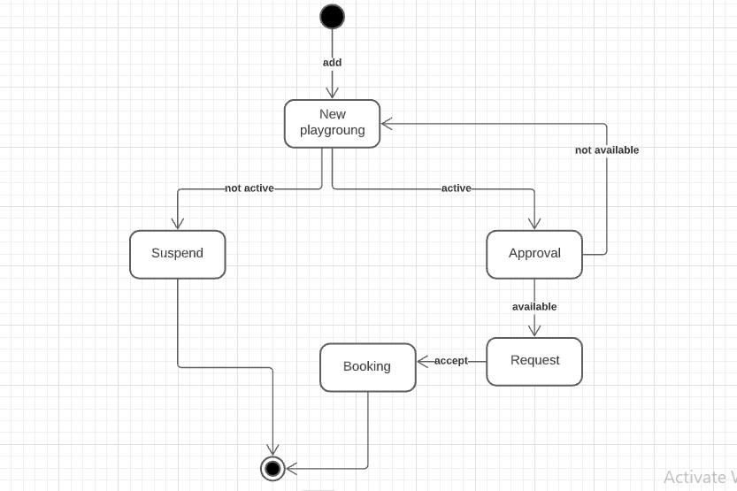

# Tools

We use:

* Lucid chart

# 

# Ownership Report

|  |  |
| --- | --- |
| **Item** | **Owners** |
| **Abdelrahman Mohamed Abdelzahir** | **Part of sequence diagram 3 and sequence diagram 4.** |
| **Abdelhaleem Mahmoud Abdelhaleem** | **Part of class diagram and**  **Class Descriptions** |
| **Rabab Soliman Khedr** | **Part of sequence diagram 1, sequence diagram 2, and state diagram** |